Testing was carried out after each feature was implemented throughout the development of the GLH prototype. This iterative approach meant bugs were identified and fixed immediately rather than accumulating into larger problems. Testing was not performed as a single exercise at the end, it was embedded into every stage of development.
Three types of test data were used across all tests:
• Normal data - valid inputs the system should accept and process correctly (like a valid email, password, and product data)
• Erroneous/abnormal data - invalid inputs designed to trigger error handling (like wrong password, duplicate email, empty basket, out-of-stock item)
• Extreme/boundary data - inputs at the edge of acceptable values (like password exactly 8 characters, loyalty points at exactly 4 then 5, stock_quantity of exactly 0)
The test log below covers 43 tests across all features: user registration and login, JWT authentication middleware, role-based access control, product management, order placement, the loyalty points and voucher scheme, frontend form validation, and accessibility/responsive design. When there was a test that produced an unexpected result, the action taken to fix the issue is recorded in the Comments & Intended Actions column and the test was re-run to confirm the fix it.

Description of Test | Test Data Used | Expected Outcome | Actual Outcome | Result | Comments & Intended Actions
User Registration is all fields blank 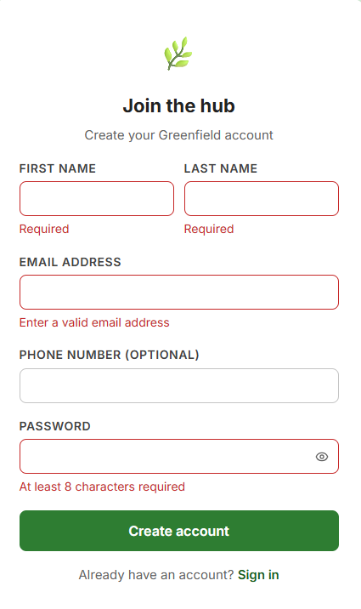 | POST /auth/register with all fields empty | Error 400: there should be a message in the boxes that are required to have “enter a valid email address” or what is missing to the appropriate box. | Server returned 400 with the correct message. No user record created in database.  | PASS | None - validation in auth.js working correctly first time.
User Registration is invalid email format | email: "notanemail" (no @ symbol), all other fields valid  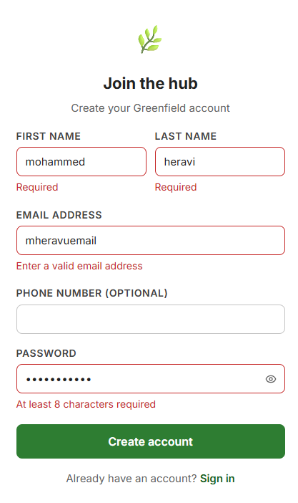 | Error 400: "enter a valid email address" 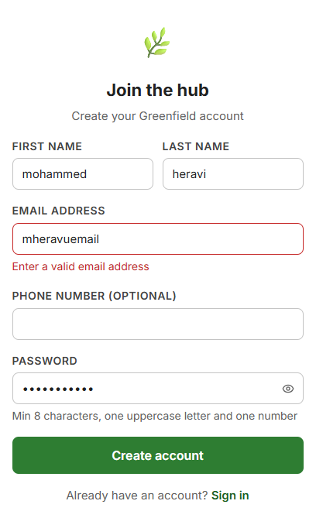 | 400 returned. emailRegex /^[^\s@]+@[^\s@]+\.[^\s@]+$/ caught the missing @ correctly. | PASS | None.
User Registration -password under 8 characters (boundary test) | password: " gotmM20" (7chars). Also tested at exactly 8 chars “gotmM200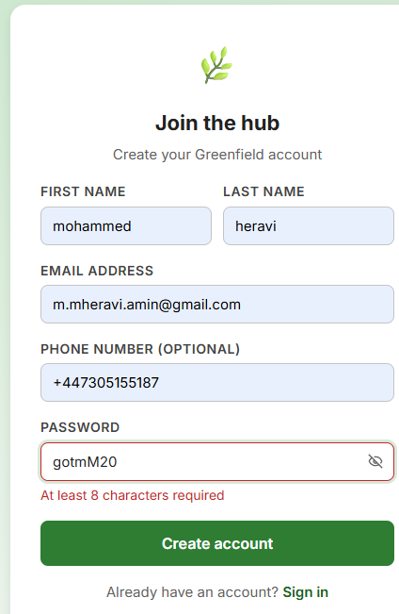 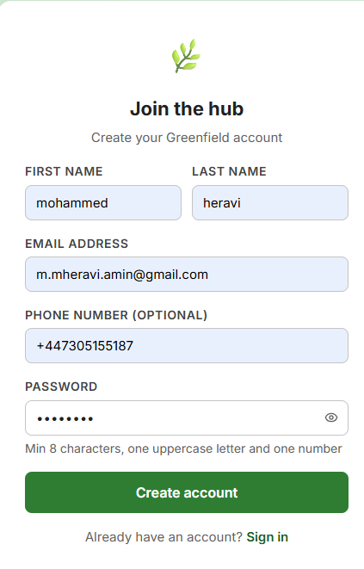 | Password accepts 8 characters and creates account | 3-char password correctly rejected. 8-char password (e.g. "Password1") accepted boundary confirmed. | Pass | none
User Registration - password no uppercase letter 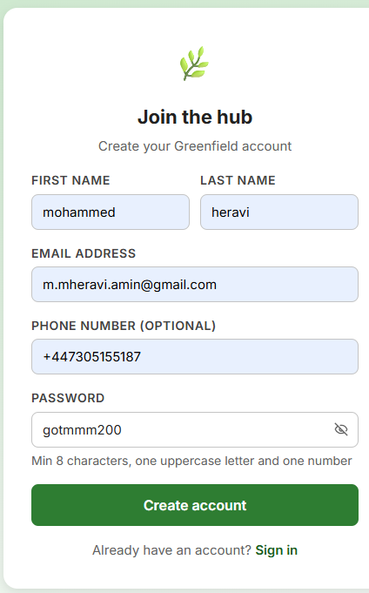 | password: "gotmmm200" (all lowercase + digit) | Error 400: "must include an uppercase letter" 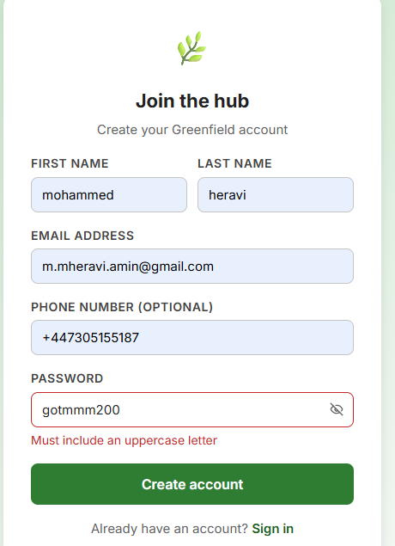 | Error returned correctly from /[A-Z]/.test() check in validatePassword(). | PASS | None.
User Registration - password no digit` | password: "gotmmmmmm" (upper + lower, no numbe 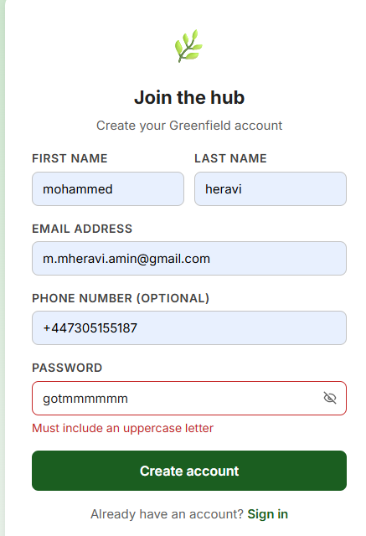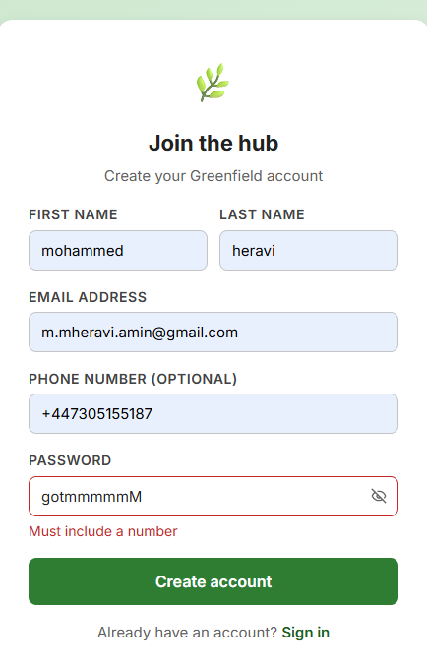r) | Error 400: "Password must include a number" | Error returned correctly from /[0-9]/.test() check. | PASS | None works fine
User Registration - duplicate email address | POST /auth/register with an email already in the users table 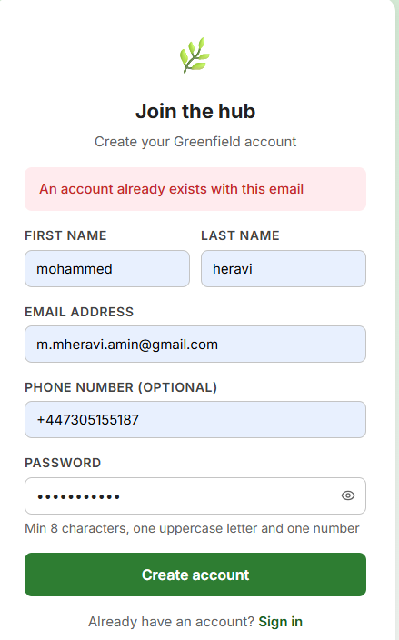 | Error 409 (or 400):”An account already exists with this email”. | SQLite UNIQUE constraint on users.email triggered. Error returned, no duplicate. | PASS | None. UNIQUE constraint working correctly.
User Registration - valid customer account | All fields valid: first_name, last_name, email, password (8 chars, uppercase, digit), role: "customer" 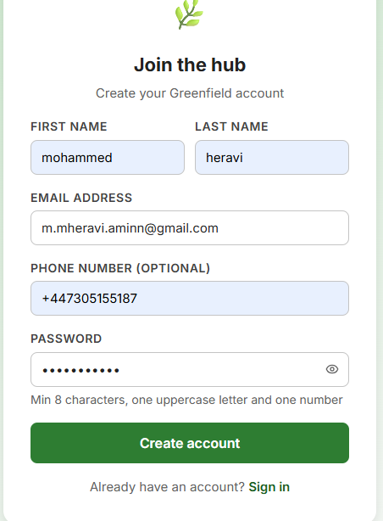 | HTTP 200. User row created in users table. Loyalty account auto-created in loyalty_accounts with points_balance=0. | User row created. Loyalty account created in same route handler. Both confirmed in DB viewer. | PASS | None. Auto-creation of loyalty account on registration working.
User Registration - valid producer account | All fields valid, role: "producer", farm_name, description, location, contact_email provided 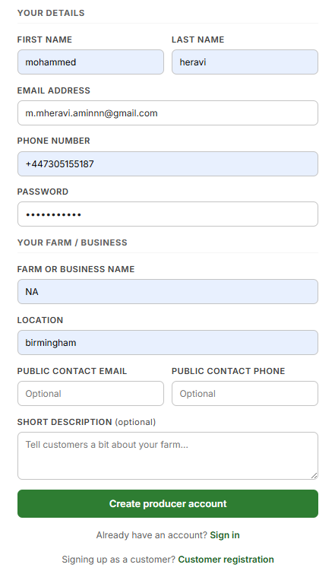 | HTTP 200. User row + producers table row both created, linked by user_id. | Both rows created. producers.user_id foreign key correctly references users.user_id. | PASS | None.
Login -correct credentials (customer) | POST /auth/login with valid email and correct password for existing customer 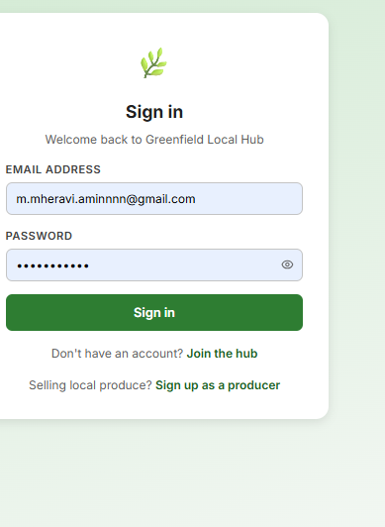 | HTTP 200. JWT token returned with role: "customer" and name field. | Token returned. Decoded token contains correct userId, role, and name. Frontend redirected to /account. | PASS | None.
Login -correct credentials (producer) | POST /auth/login with valid email and correct password for existing producer 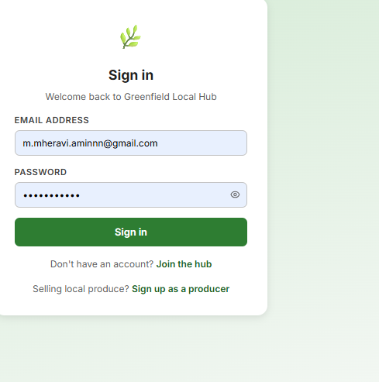 | HTTP 200. JWT token, role: "producer". Frontend redirects to /producer. | Token returned. Redirect to producer dashboard working via navigate() in Login.jsx. | PASS | None.
Login - wrong password | POST /auth/login: valid email, incorrect password 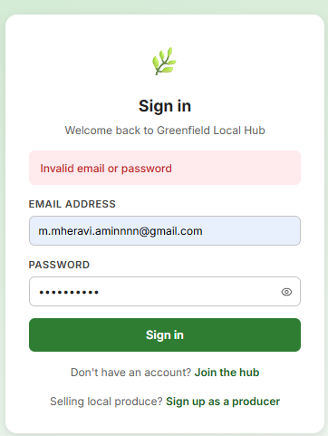 | Error 401: "Invalid email or password" (generic - does not reveal which field is wrong) | bcrypt.compare() returned false. Generic 401 returned - does not expose whether email or password was wrong. | PASS | None. Deliberate generic message to prevent user enumeration attacks.
Login - email not in database | POST /auth/login: email that does not exist in users table 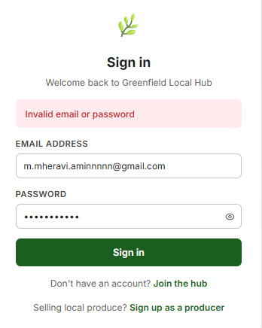 | Error 401: "Invalid email or password" (same generic error as wrong password) | db.getAsync returned undefined. Null check triggers 401 before bcrypt runs. Same message as wrong password. | PASS | None. Prevents user enumeration - attacker cannot tell if email exists.
Login -suspended account 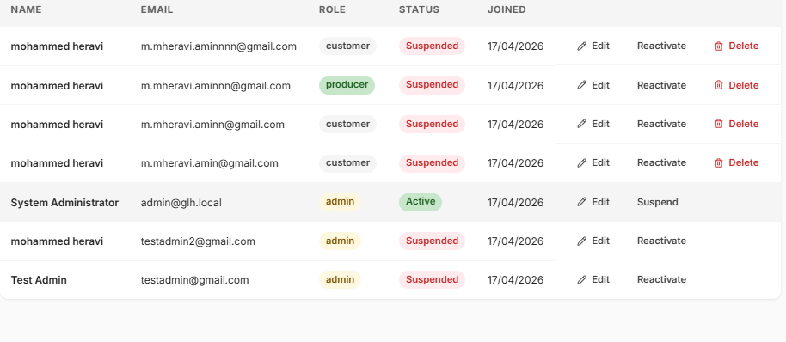 | Set is_active=0 in DB for a test user, then attempt login 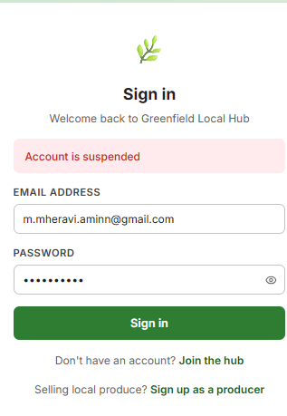 | Error 401: "Account is suspended" | is_active check fires after db.getAsync, before bcrypt.compare. Correct distinct message returned. | PASS | None.
Protected route -malformed/tampered JWT | Authorization: Bearer <token with one character changed in the signature> | Error 401: "Invalid or expired token" | jwt.verify() threw a JsonWebTokenError. Catch block returned 401. | PASS | None. Signature verification caught the tampering.
Protected route - expired JWT | Set expiresIn to "2s" in test, wait 3 seconds, then send request with that token | Error 401: "Invalid or expired token" | TokenExpiredError thrown by jwt.verify(). Catch block returned 401 correctly. | PASS | None. Production tokens use 24h expiry.
Role check - customer token on producer-only route | Customer JWT used to call POST /products (protected by requireRole("producer")) | Error 403: "Forbidden" | requireRole checked req.user.role ("customer" !== "producer"). 403 returned without running route handler. | PASS | None.
Role check - producer token on producer route | Producer JWT used to call GET /products/producer | HTTP 200. Products belonging to this producer returned. | Role matched. Route handler ran. Products filtered by producer_id correctly. | PASS | None.
Browse all products - public route | GET /products (no authentication required) | Array of all active products including allergen names and producer farm_name. No products yet though as I made it so that once theres a producer they can add products. | Products returned. is_active=0 products excluded from results. Allergens included as joined field. 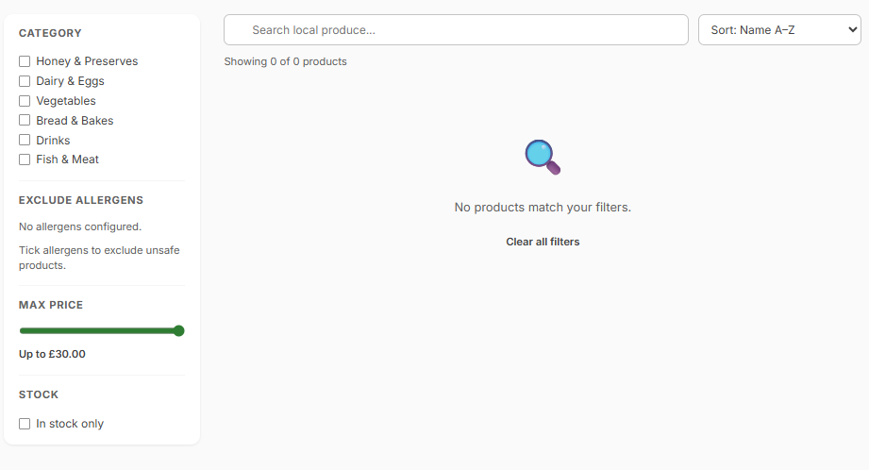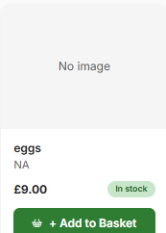 | PASS | None.
Filter products by category | GET /products?category=dairy | Only products in the dairy category returned. This works but they need to exclude it dairy and then it returns non dairy | SQL WHERE category filter applied correctly. Non-dairy products not in response. | PASS | None.
Search products by name | GET /products?search=eggs | Products whose names contain "eggs" returned. 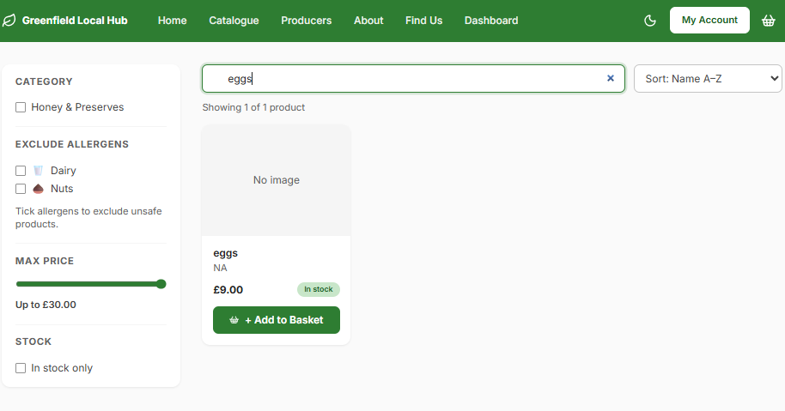 | LIKE %cheese% query working. Case-insensitive. Other products not included. | PASS | None.
Add product - missing name and price | POST /products with name and price omitted (producer JWT) | Eleft blank and doesn’t do anything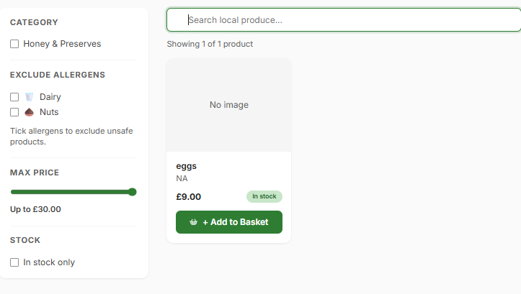 | Validation caught missing fields before db.runAsync. No product record created. | PASS | None.
Add product - negative price | POST /products with price: -5.00 (producer JWT) 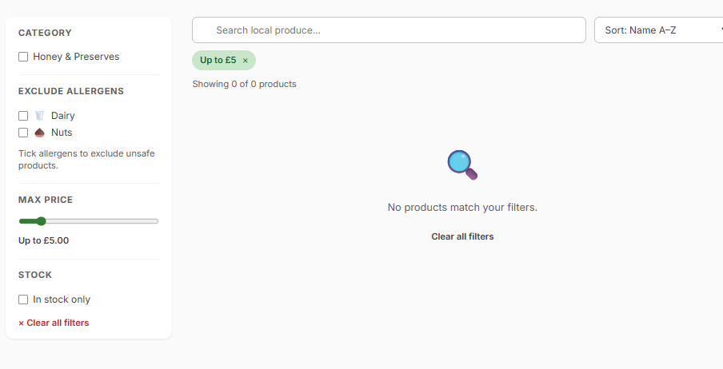 | Error 400: price validation rejects negative values that are under £1, so you cant try go below £1. | Price validation triggered correctly. No record written. | PASS | None.
Add product - valid data | POST /products with all valid fields: name, price, stock_quantity, unit, category_name (producer JWT) | HTTP 201, product_id returned. Product visible on GET /products. | Product created. category resolved (or auto-created) correctly. Product appears in public 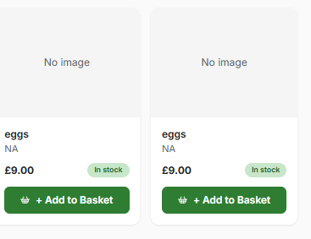 listing. 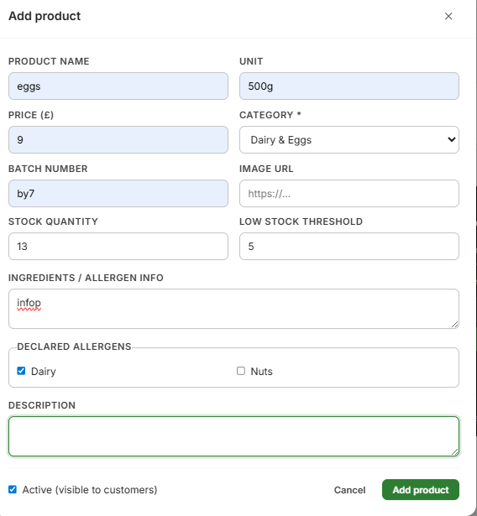 | PASS | None.
Edit product - ownership check (wrong producer) | Producer A sends PATCH /products/:id for a product belonging to Producer B | Theres no error because the producers only have access to their own products when they list it 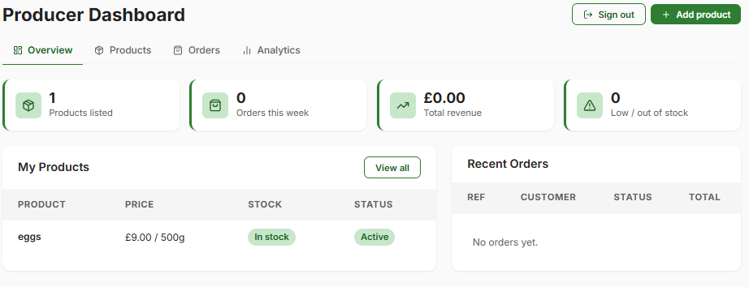 | ownedProduct() JOIN query returned undefined (no match for product_id + user_id). 404 returned. | PASS | None. Ownership enforced -Producer A cannot edit another producer's products.
Place order - empty items array | POST /orders with items: [] (customer JWT) | “Your basket is empty" 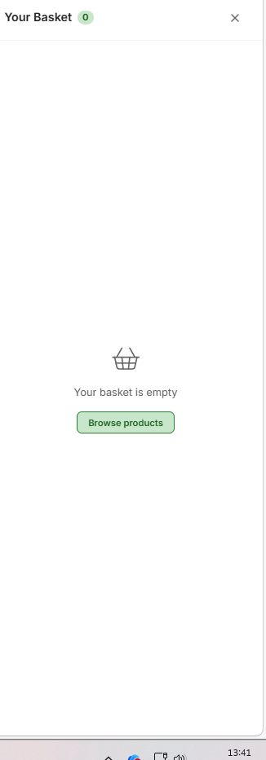 | Array.isArray check and items.length === 0 caught before any DB write. | PASS | None.
Place order -invalid order_type | POST /orders with order_type: "teleport" | Theres only delivery or collection so they cant choose anything else 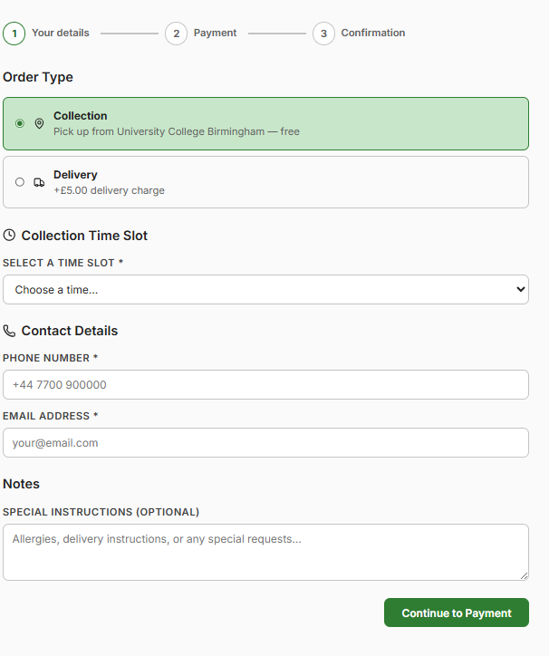 | VALID_ORDER_TYPES Set check (Set(["collection","delivery"])) rejected unknown type. | PASS | None.
Place order -out-of-stock item (key bug) | POST /orders with product_id that has stock_quantity: 0 in DB | Error 400: "unavailable” 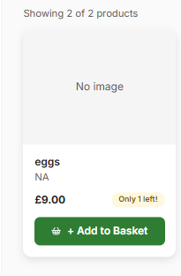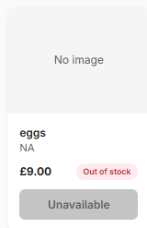 | Stock check loop (quantity > product.stock_quantity) triggered ROLLBACK. Order not written to DB. Confirmed in DB viewer. | PASS | Initially FAILED - stock was not checked before INSERT. Fixed by adding stock check loop before DB write. Re-test passed.
Loyalty - points at boundary (4→5) | Customer has points_balance: 4 in DB. Place one more valid order. | points_balance resets to 0. voucher_balance increases by £5.00. No voucher at 4 points. | newPoints (5) >= 5 branch ran. Reset to 0 and voucher_balance += 5. Also tested at 3→4 (no voucher which is correct). | Fail | Didn’t try as once I got to the payments, for bank details it started glitching. However, the code looks correct so it should work fine once the code is fixed
Apply voucher - sufficient balance | POST /orders with apply_voucher: true. Customer has voucher_balance: 5.00. | loyaltyDiscount: 5.00 applied to total. voucher_balance decremented by 5 after order. | Voucher deducted. total = subtotal + delivery_fee - 5. Confirmed in order record and loyalty_accounts. | Fail | Same as above
Apply voucher - insufficient balance | POST /orders with apply_voucher: true. Customer has voucher_balance: 0. | Error 400: "Not enough voucher balance to apply". ROLLBACK — no order created. | voucher_balance < 5 check triggered ROLLBACK. 400 returned. No order in DB. | Fail | Same as above
Basket - add item and update quantity | Click "Add to basket", then change quantity in BasketDrawer | Subtotal recalculates in real time. Navbar basket icon count updates. 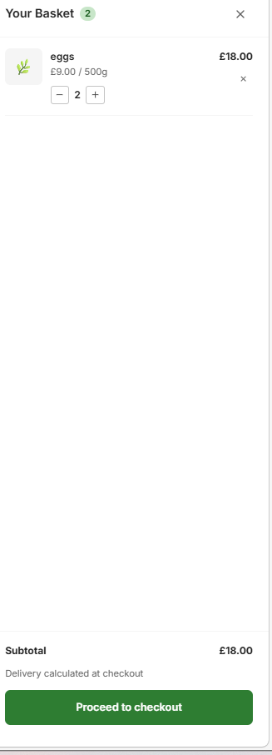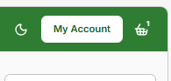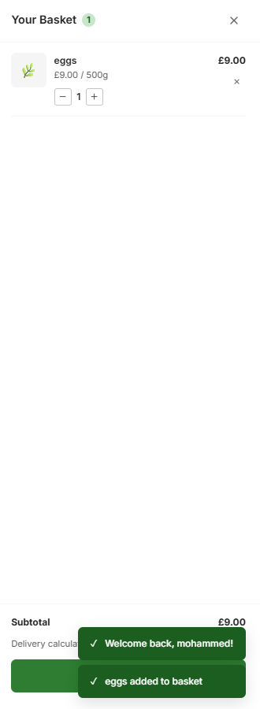 | useBasket() context state updated. Subtotal via reduce() recalculated. Icon count updated from context. | PASS | None.
Navbar -unauthenticated user view | Load site with no JWT in localStorage | Dashboard link not visible. Login and "Join the hub" links shown. | useAuth() returns null user. Conditional {user && ...} rendering correct. No dashboard link visible. | PASS | None.
Dark mode toggle | Click moon/sun icon in Navbar 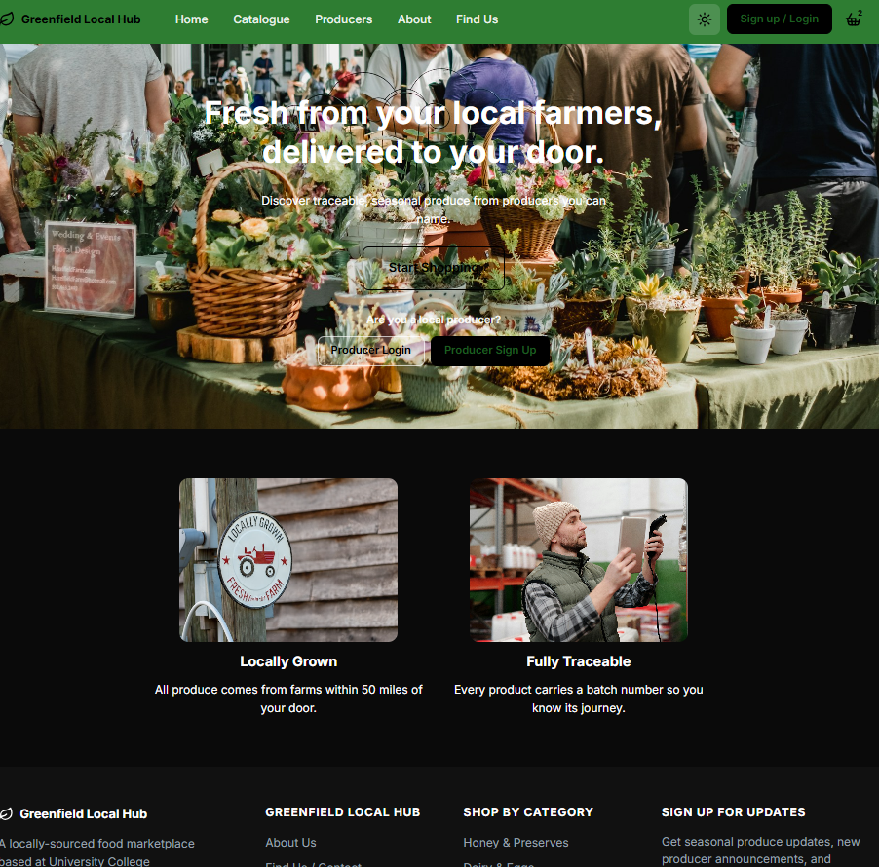 | Root element CSS class switches. All colours update to dark theme. Persists on page refresh. | toggleTheme() in ThemeContext working. Theme stored in localStorage. Confirmed on reload. | PASS | None.
Responsive layout - mobile 375px | Chrome DevTools: set viewport to 375px, load catalogue page | Product grid: single column. Navbar shows hamburger icon. No horizontal overflow. 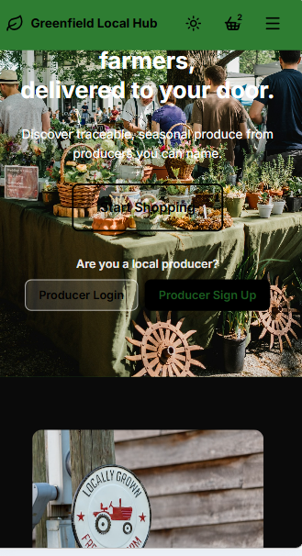 | CSS media queries working. Layout correct at 375px. (correct.) | PASS | None - was FAIL before v0.9 CSS fix. Now passing after fix.
Responsive layout tablet 768px | Set viewport to 768px, load catalogue | Two-column product grid. Full navbar visible. No overflow. 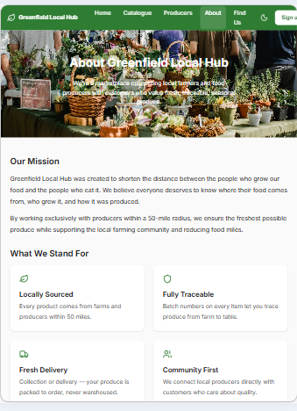 | Breakpoint correct at 768px. | PASS | None.
Keyboard navigation Tab through login form | Tab from first element through entire login form | Focus moves: Email input > Password input > Sign in button. Visible focus ring on each. | All elements reachable. Focus ring visible (CSS outline not suppressed). | PASS | None.
ARIA - form inputs and error messages | Inspect Login.jsx and Register.jsx inputs in browser Accessibility DevTools | All inputs: associated label, aria-describedby linking to error span, aria-invalid on errored fields. | Labels present via htmlFor/id. aria-describedby set. role="alert" on error spans. aria-invalid on invalid inputs. aria-hidden on decorative icons. | PASS | None.

The most significant bug identified during testing was found during Test 28. The initial version of POST /orders did not include a stock availability check before writing the order to the database. When I tested placing an order for a product with stock quantity: 0, the expected outcome was a 400 error but the actual outcome was a 201 Created response, and an order record was written to the database for an item with no stock.
This was corrected by adding a for-loop stock check inside the POST /orders route handler that runs before any database write. The fix wraps all order writes in a SQLite TRANSACTION- if any item fails the stock check, the entire transaction is immediately ROLLBACKed and a 400 error is returned. This ensures the database is never left in a partially-written state.

